# 

Create a own library in JitPack

Contents

How to create an own library in android? 2

Public Repositories: 10

Private Repositories: 12

# How to create an own library in android?

* This is demo library and it’s only printing the logs message.
* Create a new project as shown in below picture:

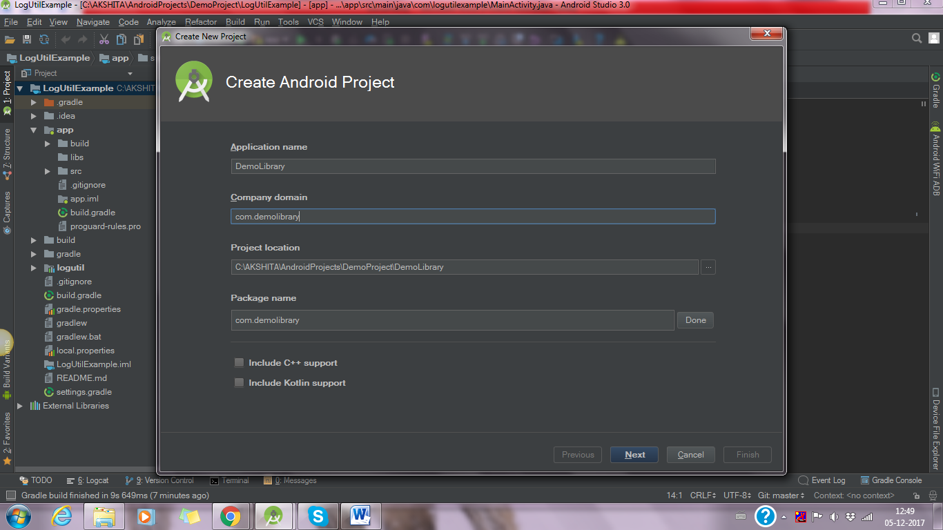

* Select Empty Activity and finish it.
* Now create a module (right click of android app and select New -> Module) as shown in below picture:

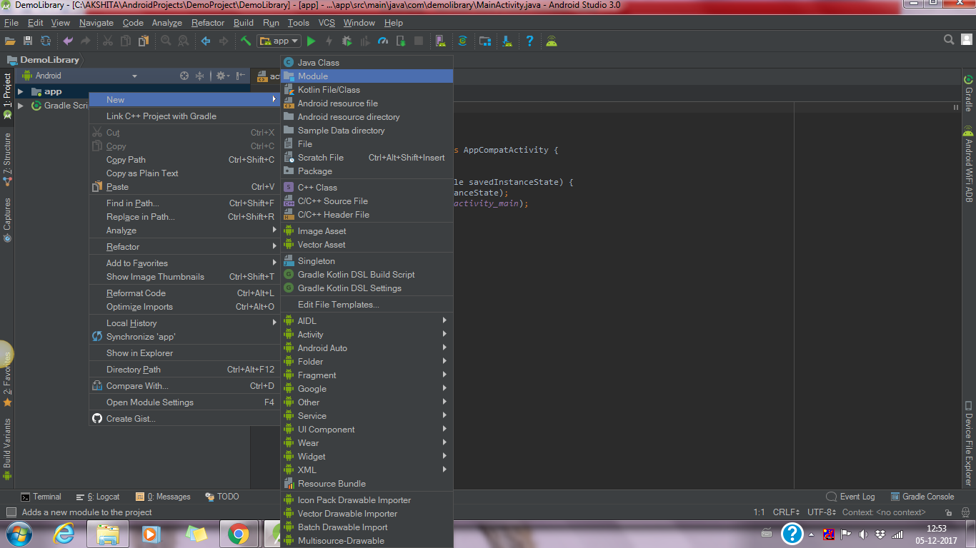

* Now choose Android Library as shown in picture:

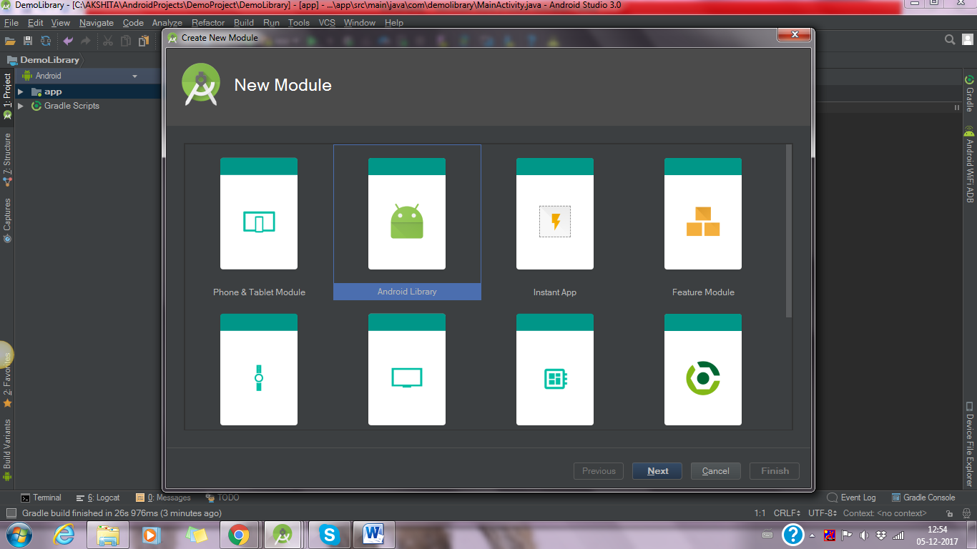

* Click on next and set a name of library what you want as shown in below picture:

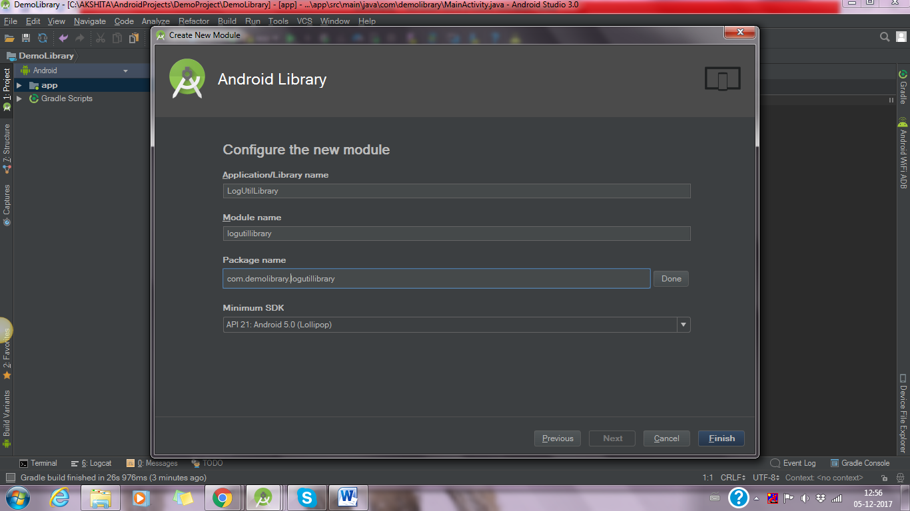

* Now click on finish button. It create a library module and it will be seen as below picture:

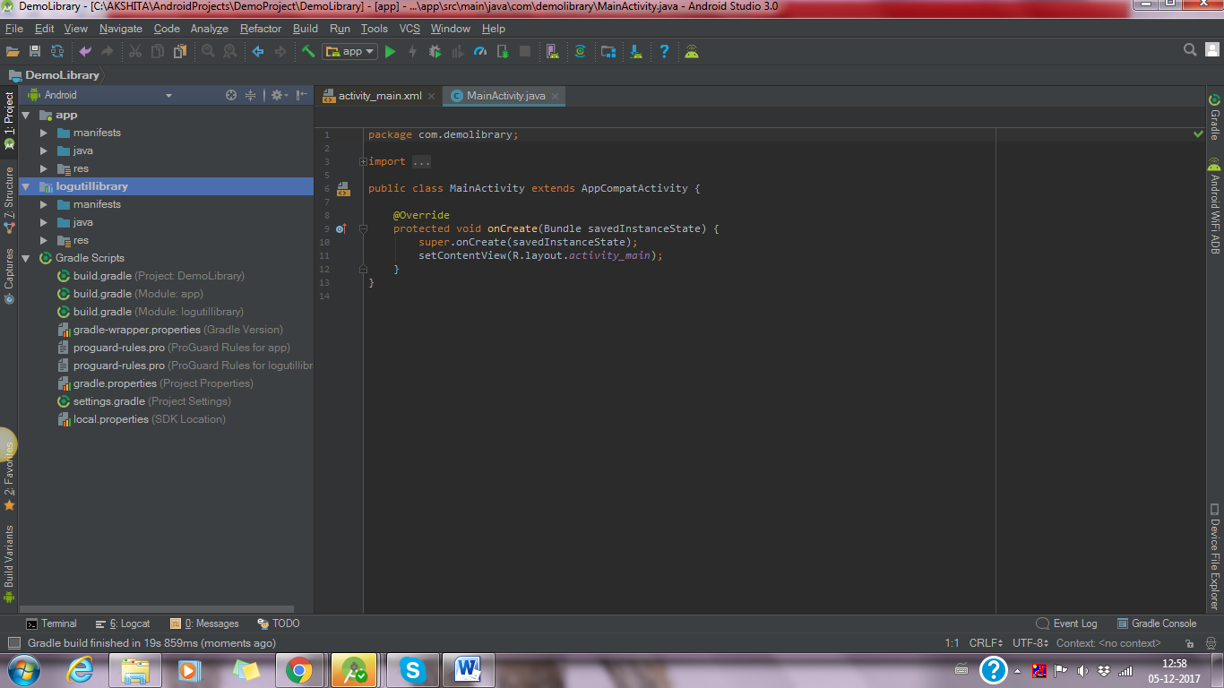

* Now create a class in library folder as shown in below picture:

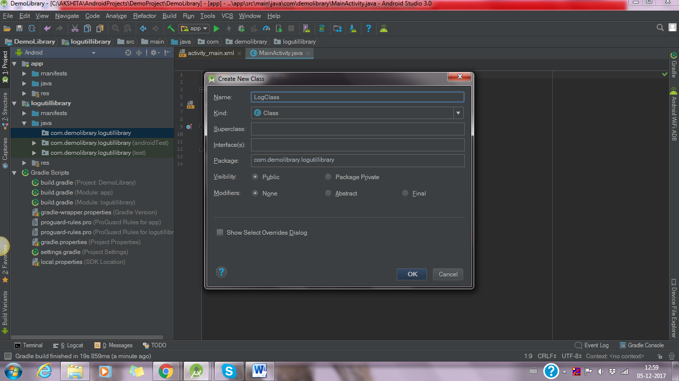

* This class contains all logs method so it prints the message as shown in below picture:

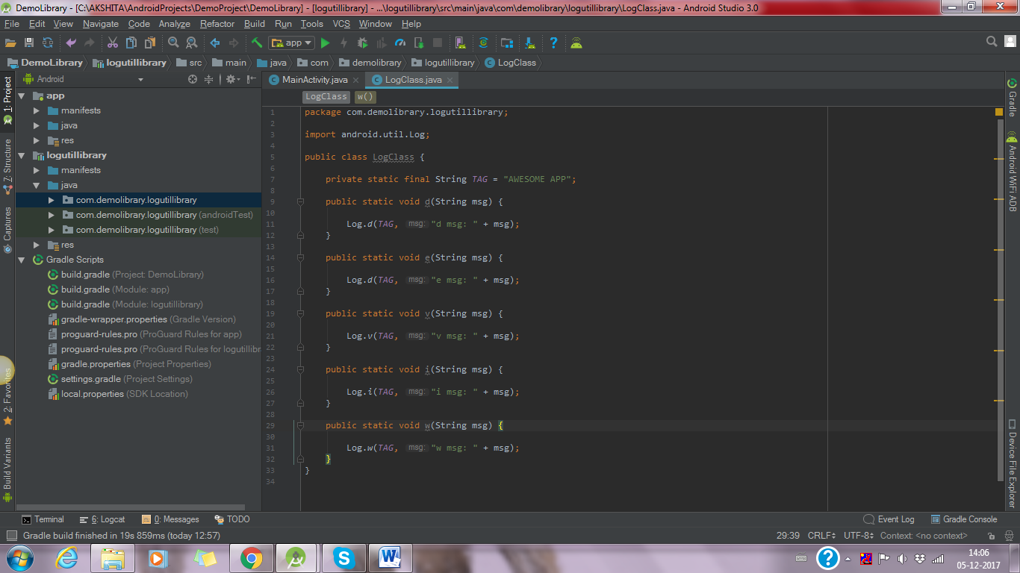

* Add this library in your build.gradle (module:app)

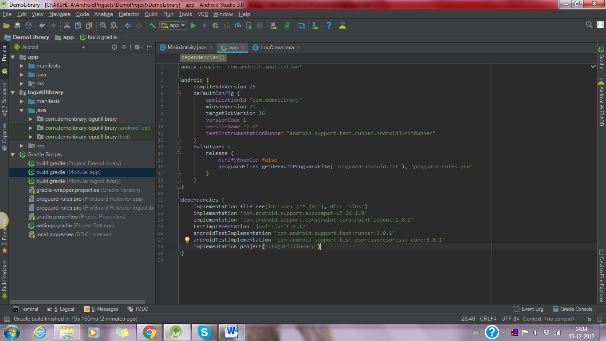

* Now this code pushes in your Github repositories. And then open this link : <https://jitpack.io/>
* It shows like below picture:

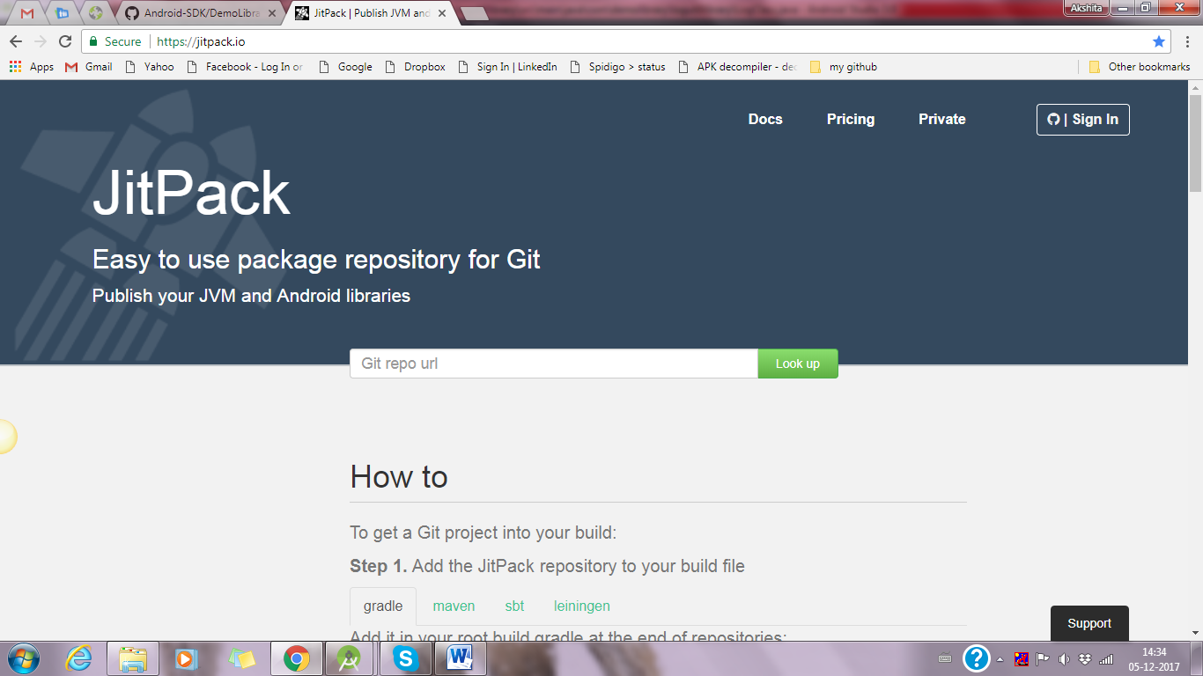

* Add your gitHub URL as shown in below picture and click on Look up. This shows in github repositories “no release found”:

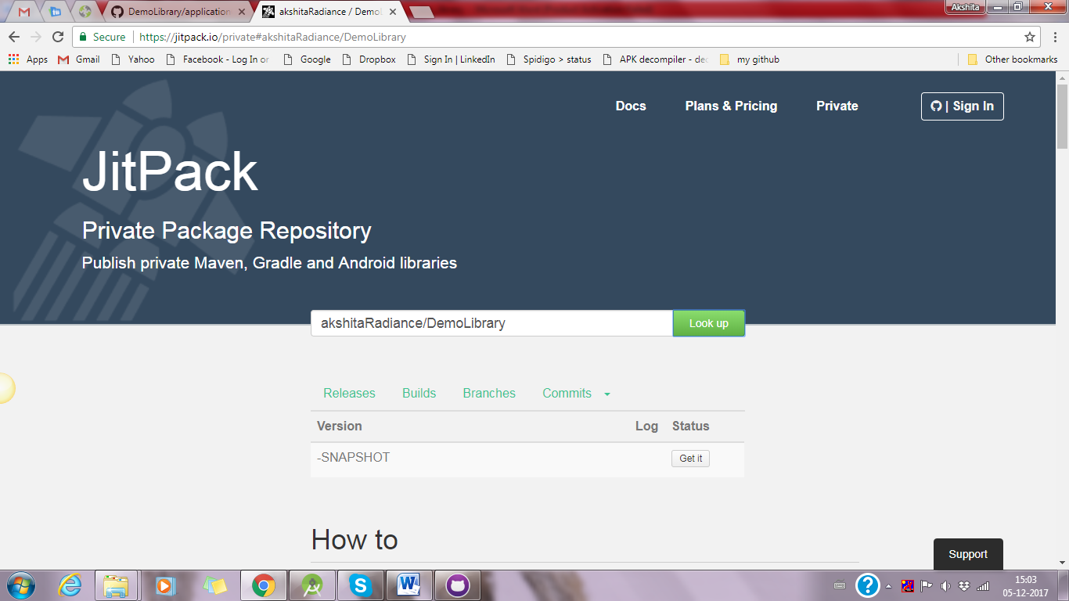

* Now first you release your repositories as shown in below picture:

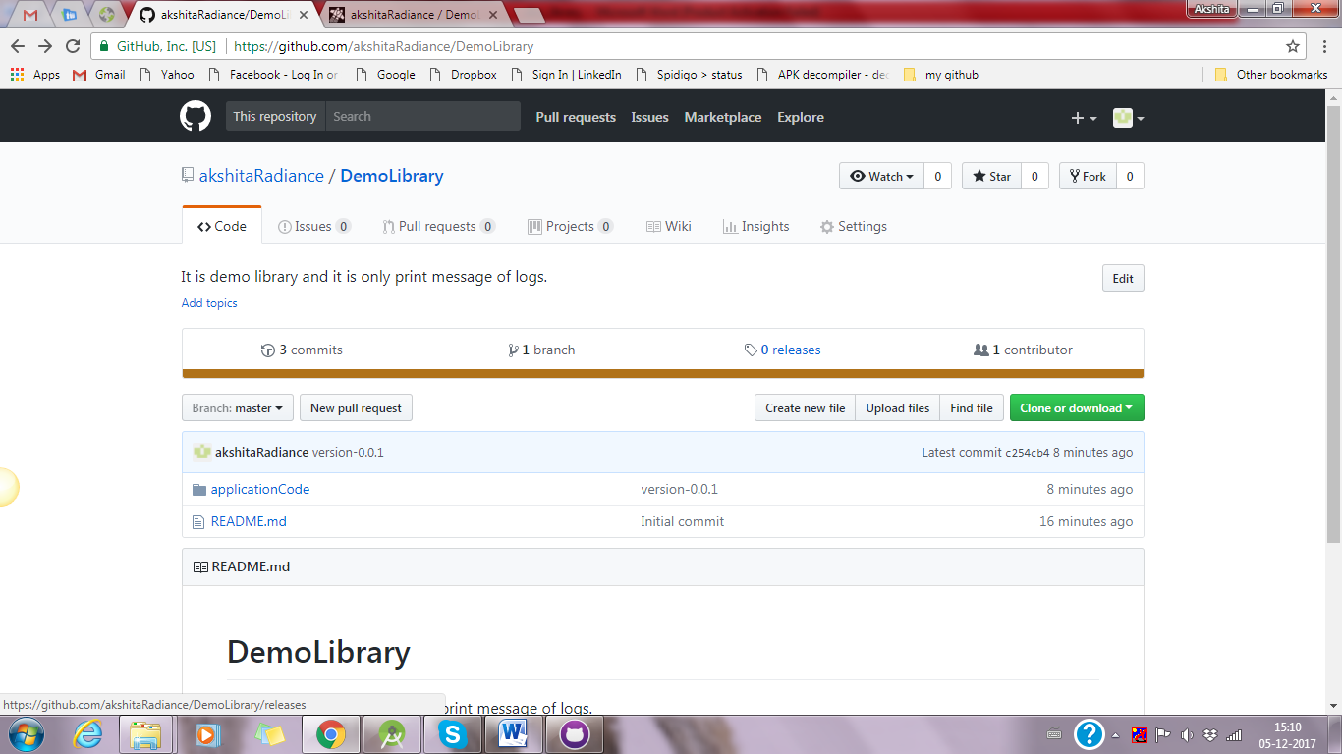

* Create a new release as shown in below picture:

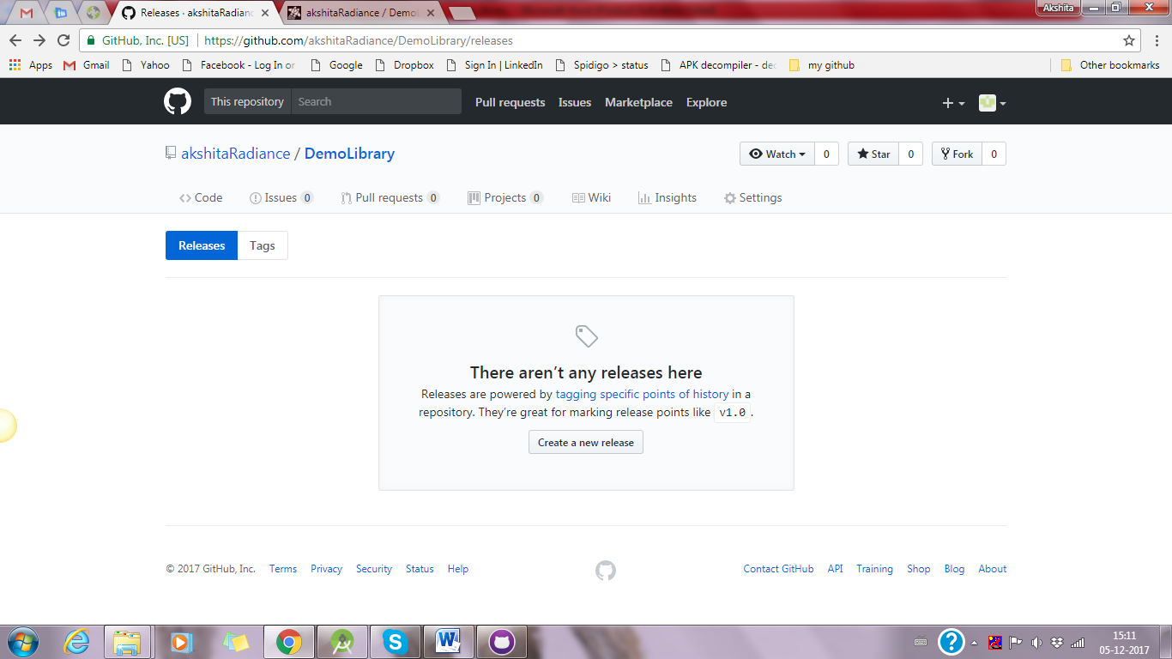

* Fill all necessary details and do publish release as shown in below picture:

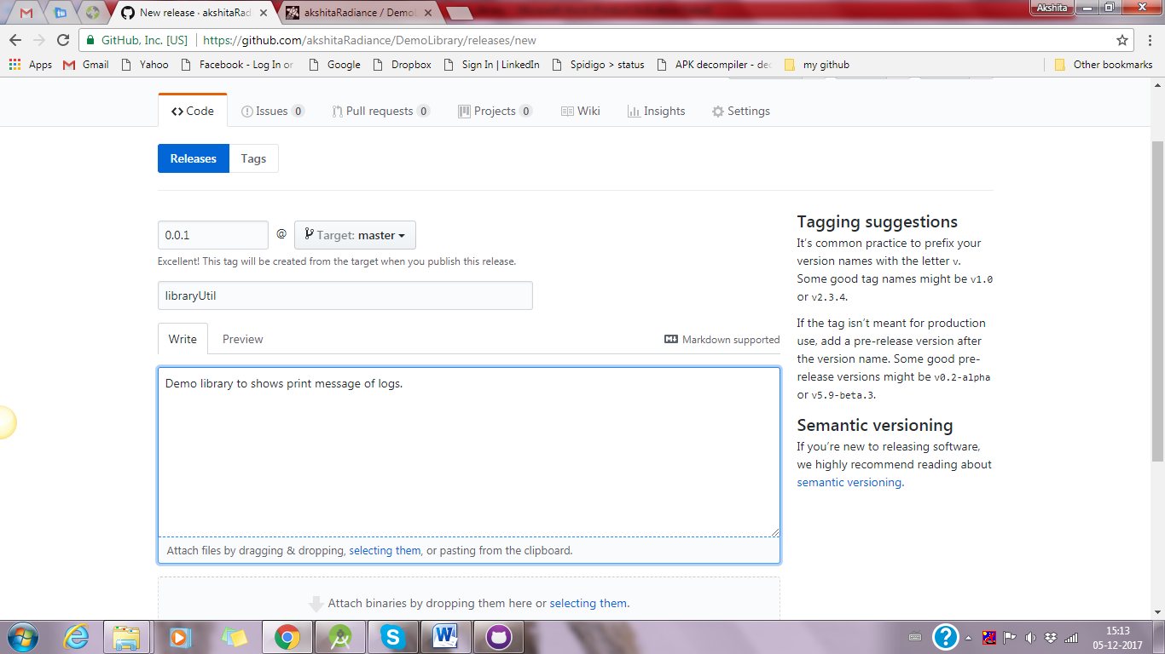

* Then you see release library as given below picture:

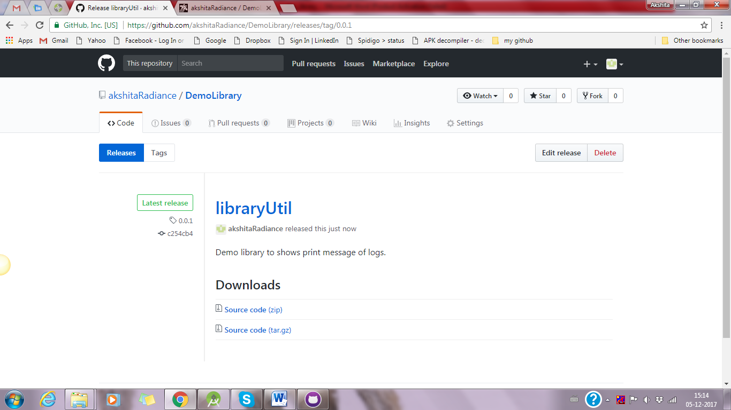

* Now in jitpack.io enter your URL again and refresh it. You can see like below picture:
* In this picture release version 0.0.1 shows some error and 0.0.2 shows that use that it is done with all process and ready to use.

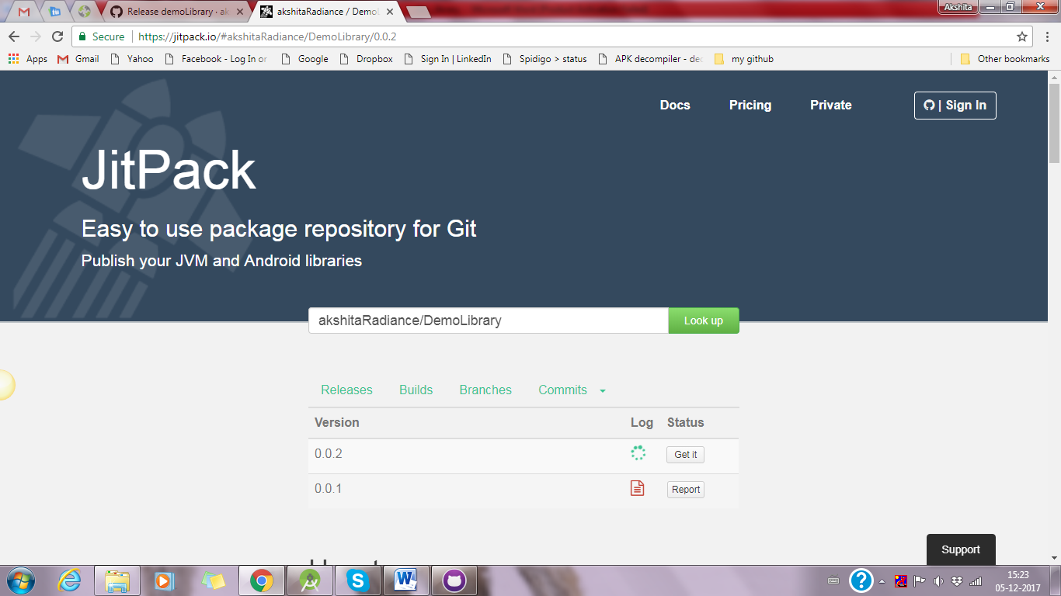

# Public Repositories:

* Click on Get It button and in bottom you can see that link of library as shown in below picture:
* It shows how to use public repo in jetpacks’.

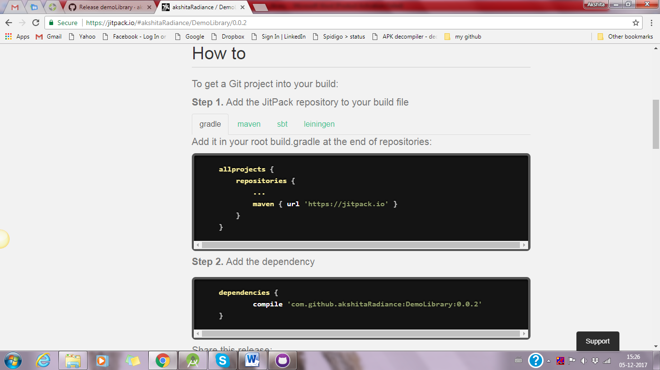

* Now this link use in your any project. And show that link is working properly or not. Given pictures shows all codes and outputs:

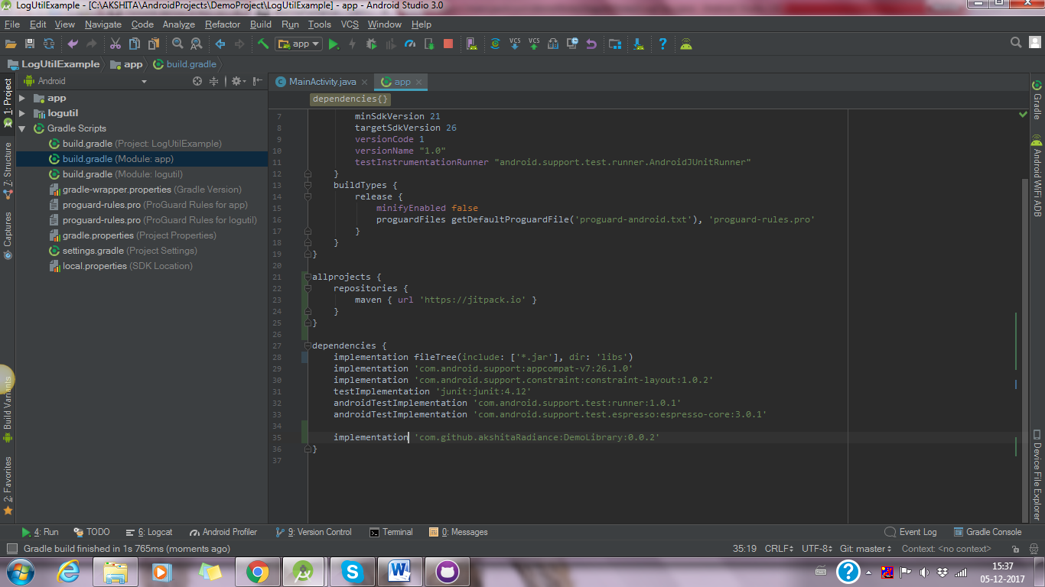

* Shows selected area as output of that logs in below picture:

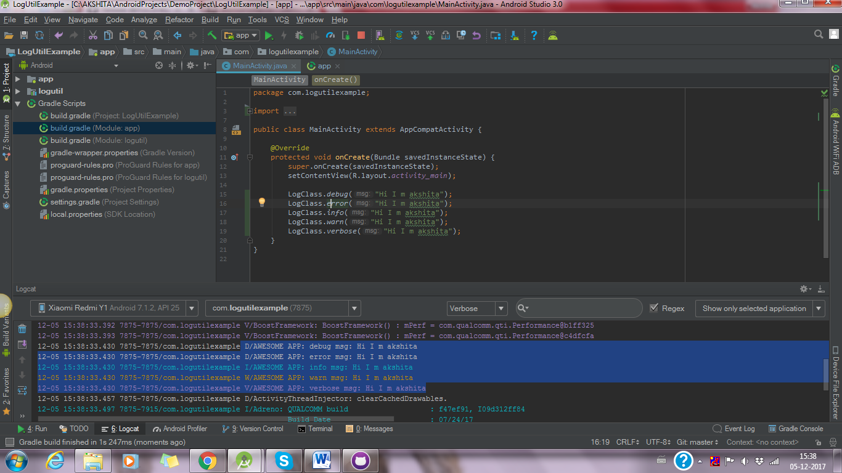

* It’s all done for public repo of github!

# Private Repositories:

* If you are using private gitHub repo, please signing in <https://jitpack.io/>
* Now you can see one Access Token as given below picture:

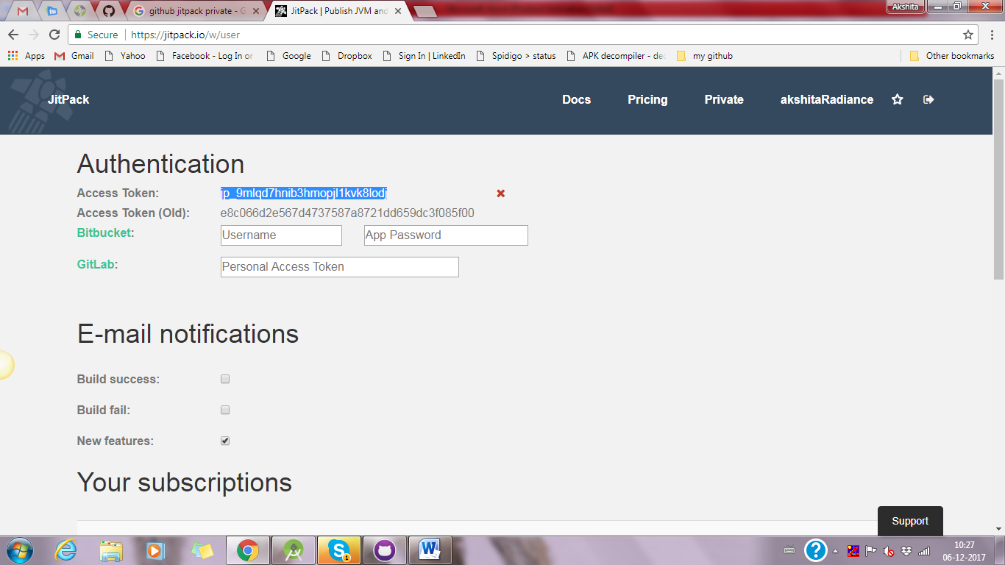

* Use this access token in android studio for that refer this link: <https://jitpack.io/private>
* It shown in below picture:

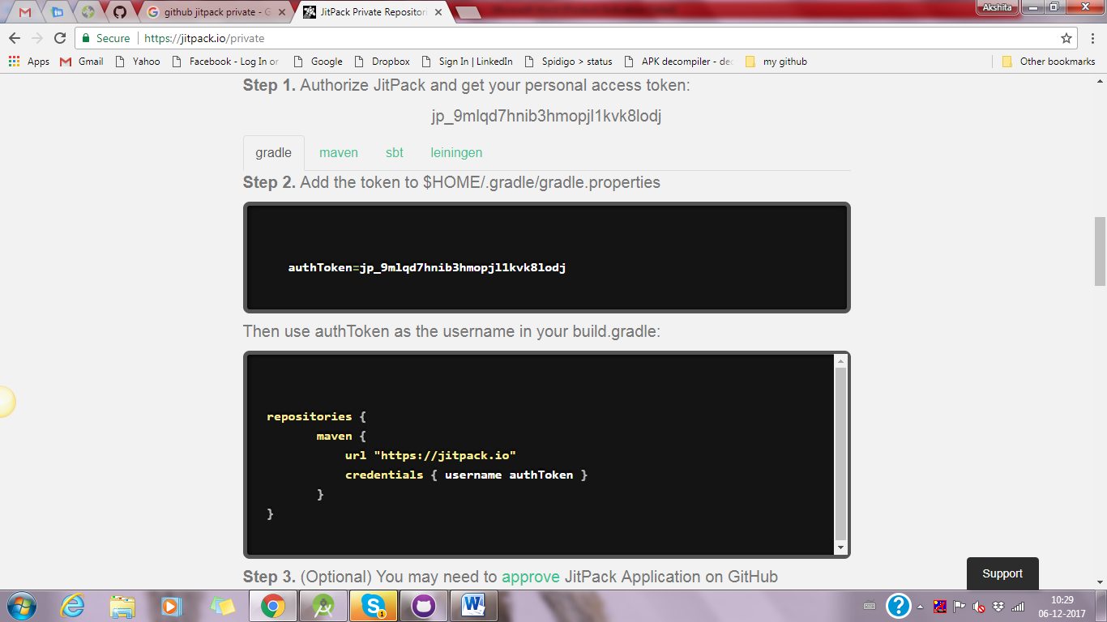

* Any project you are using that gradle library first add authToken in **gradle.properties** file, you can use it like below picture:

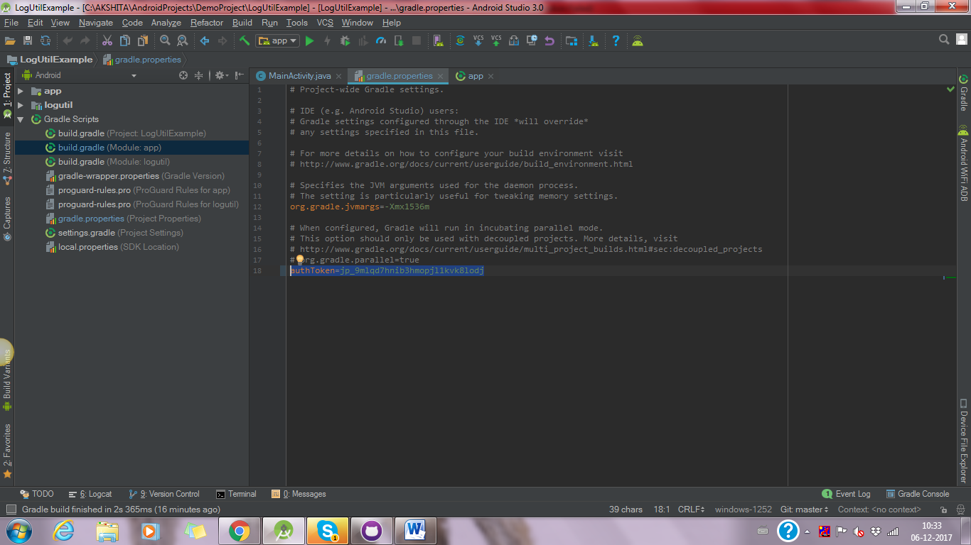

* Now in build.gradle (Module: app) add authToken as username shown in given below picture:

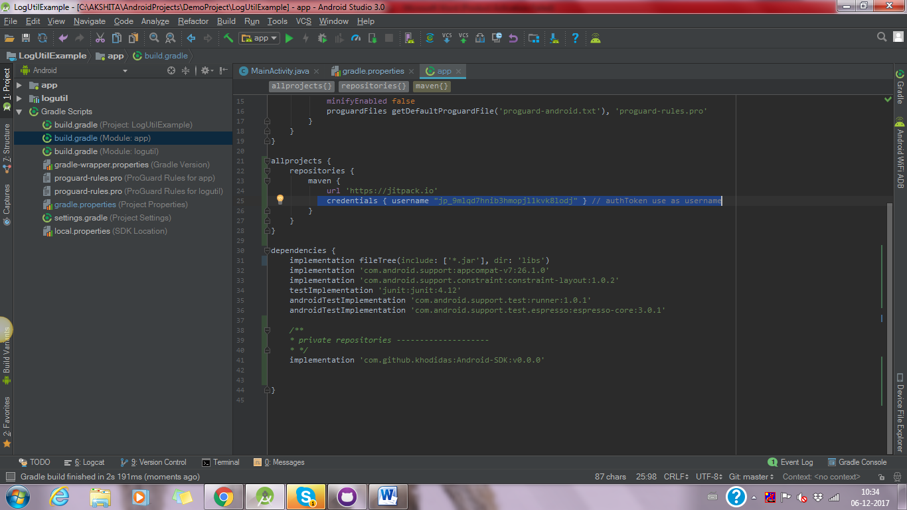

* It’s all done! This way you can use all the functionality of your private github repo.